digital tube display experiment

Overview：
这个实验通过使用一个数码管显示数字。

Materials：
Arduino Uno x 1
digital tube sensor x 1
DuPont wires x 12
220Ωresistor x 8
breadboard x 1

Product description :
Digital tube is a common display digital display, daily life, for example: electromagnetic oven, full automatic washing machine, solar water temperature display, electronic clock... And so on the number of not very few. To control the display of digital control principle, it is necessary to
The cathode of field digital tube, digital tube display digital tube is a kind of semiconductor light emitting devices, the basic unit is the light-emitting diode, digital tube according to the number of segments is divided into seven segment digital tube and eight digital tube, eight digital tube than seven segment digital tube more than a light emitting diode unit (more than one decimal point), the use of eight digital tube. According to the light emitting diode unit connection mode is divided into common anode and cathode nixie tube. Yang digital tube is refers to all the light emitting diode anode received together form a common anode (COM) digital tube anode in the application should be public com received + 5V, when a light emitting diode for low electricity at ordinary times When a field of cathode for high electric power, the corresponding field is not bright. Common cathode digital tube is all led to form a common cathode (COM) digital tube. Common cathode digital tube in the application should be COM to the ground GND, when a field light-emitting diode anode for high power, the corresponding field is lit. When a field of anode for low power, the corresponding field is not bright.
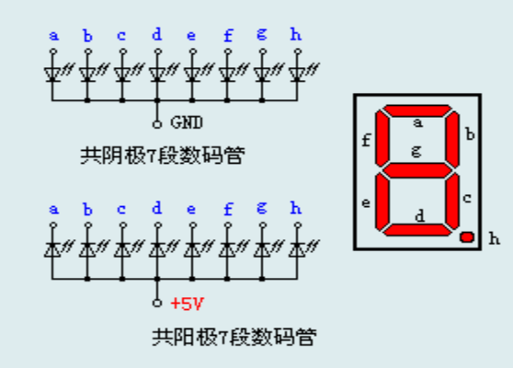

Wiring diagram:
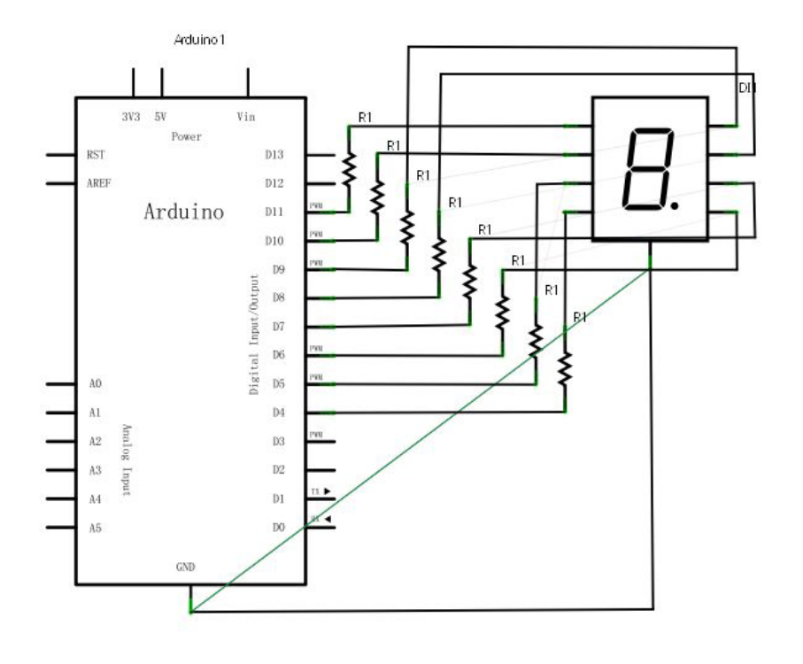
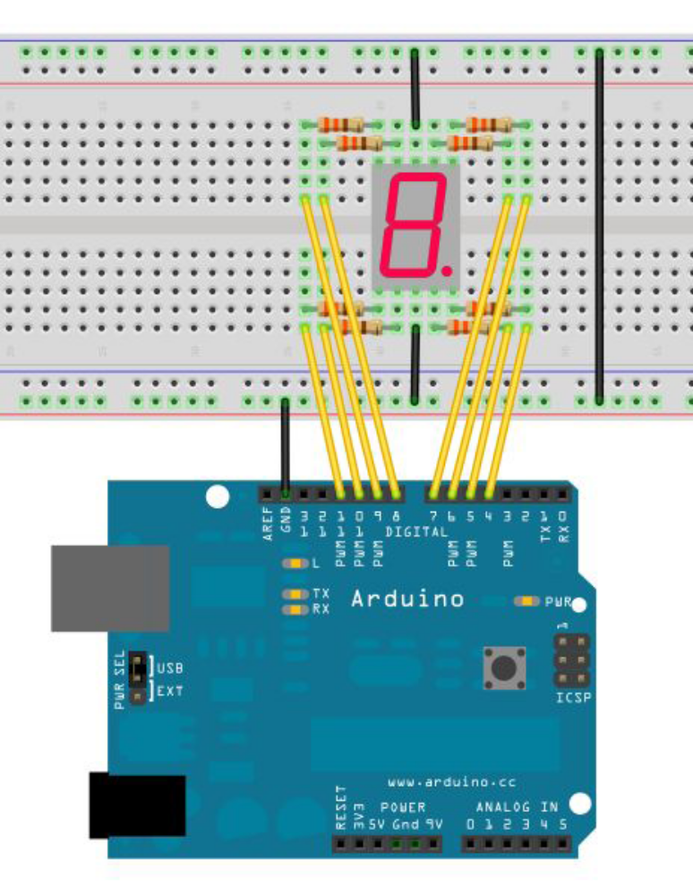

Example code:
//Set pin control all digital IO
int a=7;//Definition of digital interface 7 connected a segment digital tube
int b=6;// Definition of digital interface 6 connected B segment digital tubeint c=5;// Definition of digital interface 5 connected C segment digital tube
int d=10;// Definition of digital interface 10 connected D segment digital tube
int e=11;// Definition of digital interface 11 connected e segment digital tube
int f=8;// Definition of digital interface 8 connected f segment digital tube
int g=9;// Definition of digital interface 9 connected g segment digital tube
int dp=4;// Definition of digital interface 4 connected DP segment digital tube
void digital_0(void) //Display number 5
{
unsigned char j;
digitalWrite(a,HIGH);
digitalWrite(b,HIGH);
digitalWrite(c,HIGH);
digitalWrite(d,HIGH);
digitalWrite(e,HIGH);
digitalWrite(f,HIGH);
digitalWrite(g,LOW);
digitalWrite(dp,LOW);
}
void digital_1(void) //Display number 1
{
unsigned char j;
digitalWrite(c,HIGH);//Digital interface to the 5 pin high, lit C segment
digitalWrite(b,HIGH);//Light B segment
for(j=7;j<=11;j++)//Extinguish the rest
digitalWrite(j,LOW);
digitalWrite(dp,LOW);//Put out the DP segment of the decimal point
}
void digital_2(void) //Display number 2
{
unsigned char j;
digitalWrite(b,HIGH);
digitalWrite(a,HIGH);
for(j=9;j<=11;j++)
digitalWrite(j,HIGH);
digitalWrite(dp,LOW);
digitalWrite(c,LOW);
digitalWrite(f,LOW);
}
void digital_3(void) //Display number3
{
digitalWrite(g,HIGH);
digitalWrite(a,HIGH);
digitalWrite(b,HIGH);
digitalWrite(c,HIGH);
digitalWrite(d,HIGH);
digitalWrite(dp,LOW);
digitalWrite(f,LOW);
digitalWrite(e,LOW);
}
void digital_4(void) //Display number 4
{
digitalWrite(c,HIGH);
digitalWrite(b,HIGH);
digitalWrite(f,HIGH);
digitalWrite(g,HIGH);
digitalWrite(dp,LOW);
digitalWrite(a,LOW);
digitalWrite(e,LOW);
digitalWrite(d,LOW);
}
void digital_5(void) //Display number 5
{
unsigned char j;
digitalWrite(a,HIGH);
digitalWrite(b, LOW);
digitalWrite(c,HIGH);
digitalWrite(d,HIGH);
digitalWrite(e, LOW);
digitalWrite(f,HIGH);
digitalWrite(g,HIGH);
digitalWrite(dp,LOW);
}
void digital_6(void) //Display number 6
{
unsigned char j;
for(j=7;j<=11;j++)
digitalWrite(j,HIGH);
digitalWrite(c,HIGH);
digitalWrite(dp,LOW);
digitalWrite(b,LOW);
}
void digital_7(void) //Display number7
{
unsigned char j;
for(j=5;j<=7;j++)
digitalWrite(j,HIGH);
digitalWrite(dp,LOW);
for(j=8;j<=11;j++)
digitalWrite(j,LOW);
}
void digital_8(void) //Display number 8
{
unsigned char j;
for(j=5;j<=11;j++)
digitalWrite(j,HIGH);
digitalWrite(dp,LOW);
}
void digital_9(void) //Display number 5
{
unsigned char j;
digitalWrite(a,HIGH);
digitalWrite(b,HIGH);
digitalWrite(c,HIGH);
digitalWrite(d,HIGH);
digitalWrite(e, LOW);
digitalWrite(f,HIGH);
digitalWrite(g,HIGH);
digitalWrite(dp,LOW);
}
void setup()
{
int i;//defined variable
for(i=4;i<=11;i++)
pinMode(i,OUTPUT);//Set the 11 to 4 pin for the output mode
}
void loop()
{
while(1)
{
digital_0();//Display number 1
delay(1000);//delay 1s
digital_1();//Display number 1
delay(1000);//delay 1s
digital_2();//Display number2
delay(1000); //delay 1s
digital_3();//Display number3
delay(1000); //delay 1s
digital_4();//Display number 4
delay(1000); //delay 1s
digital_5();//Display number 5
delay(1000); //delay 1s
digital_6();//Display number 6
delay(1000); //delay 1s
digital_7();//Display number7
delay(1000); //delay 1s
digital_8();//Display number 8
delay(1000); //delay 1s
digital_9();//Display number 9
delay(1000); //delay 1s
}
}

Experimental phenomena：
digital tube display 0-9 cycle display.

